Step 1: search and create availability set

(This step has to be done before VMs are created. If VMs are created, they have to be recreated.)

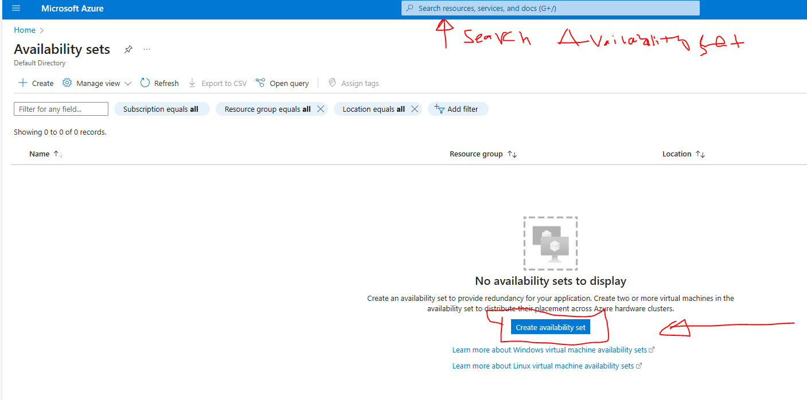

Step 2: provide resource group and AVailablity set Name

Step 3: REVIEW + CREATE